Exercise Sheet – The Circle as a Transition Ritual

See the full exercise description here:
https://brianfrandsen.com/en/cirklen-som-overgangsritual/

Step 1 – What has been

Turn one card at a time.

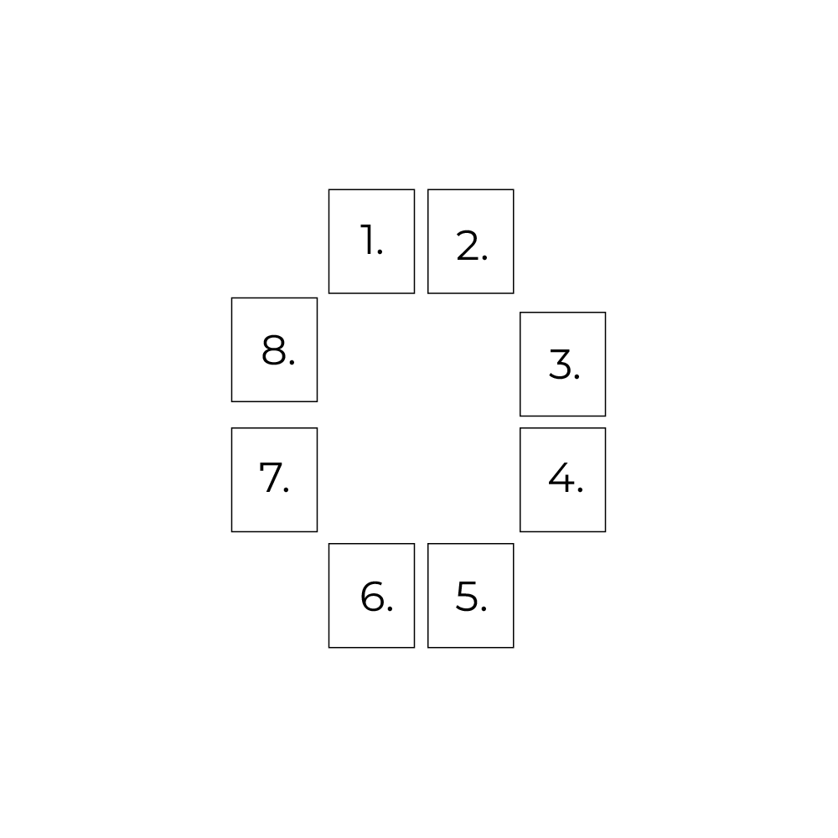
Note words, symbols, moods, and sensations..

Out of winter (card 2):
What were my dreams?
Into spring (card 3):
What opportunities appeared?
Out of spring (card 4):
What did I give my attention to?
Into summer (card 5):
What supported me?
Out of summer (card 6):
What grew the most?
Into autumn (card 7):
What was my harvest like?
Out of autumn (card 8):
What did I learn?
Into winter (card 1):
What am I in the process of letting go of?

Step 2 – What is on its way
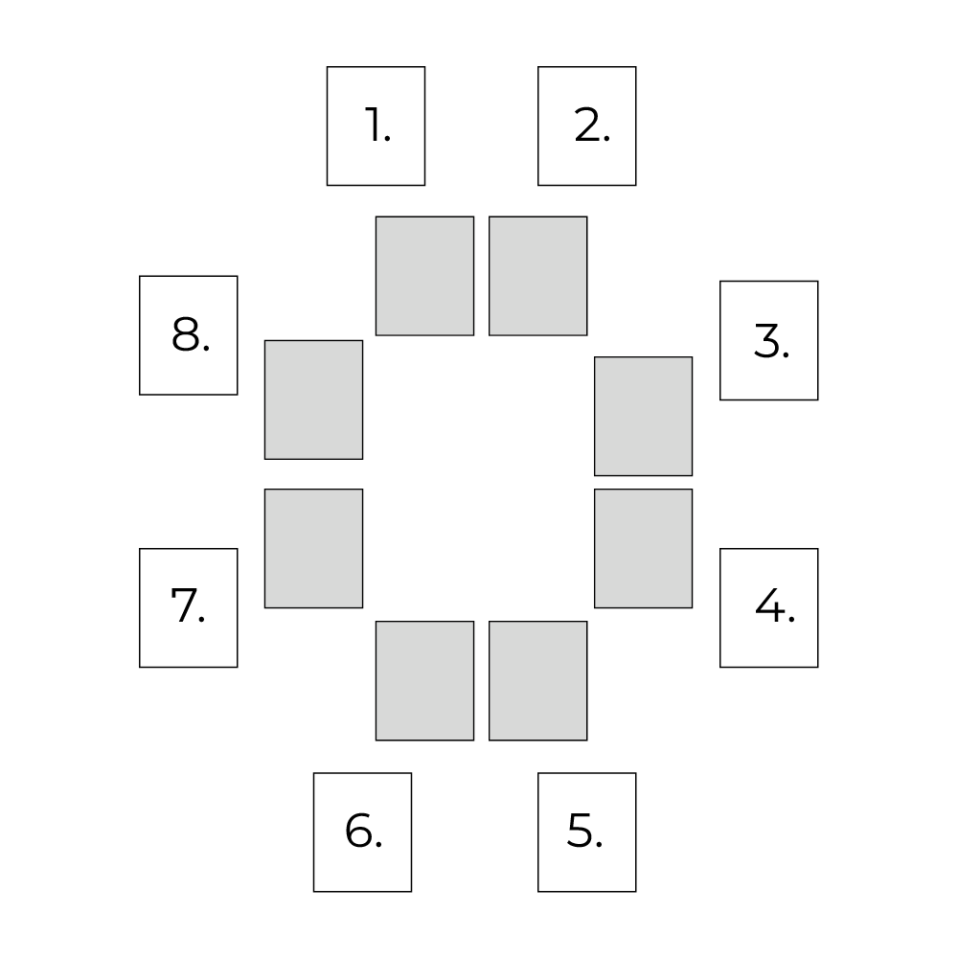
Place 8 new cards around the circle. Repeat the process.

Out of winter (card 2):
What do I dream of?
Into spring (card 3):
What opportunities will appear?
Out of spring (card 4):
Where should I focus my energy?
Into summer (card 5):
What supports me?
Out of summer (card 6):
What will grow the most?
Into autumn (card 7):
What will my harvest be like?
Out of autumn (card 8):
What will I learn?
Into winter (card 1):
What will I let go of?

Step 3 – Closing

- Look at both circles together.
- Note patterns and repetitions.
- End with a moment of gratitude.

Organisational version (team / leadership group)

Process

- Turn one card at a time.
- Everyone writes notes individually and in silence.
- No sharing during the process.

Sharing

When the entire circle has been completed (first circle 1, then circle 2), each participant shares by starting with:

“What the images as a whole tell me is …”

The focus is on the movement of the circle as a whole – not on individual cards.

Joint dialogue

- After circle 1:

What are we in the process of letting go of to make space for something new?

- After circle 2:

What do we need to learn more about in the coming period?

Closing

- No decisions are required.
- Note shared themes and tensions.
- Use the insights as a starting point for next steps.
Notea

Looking back:

What were my dreams?

What opportunities appeared?

What did I give my attention to?

What supported me?

What grew the most?

What was my harvest like?

What did I learn?

What am I in the process of letting go of?

Looking ahead:

What do I dream of?

What opportunities will appear?

Where should I focus my energy?

What supports me?

What will grow the most?

What will my harvest be like?

What will I learn?

What will I let go of?

